3. React-JS HOL

Name:- Shubham Sangram Bej

Objective
- Understand Function Components in React.
- Apply CSS styling to React Components.
- Pass data using Props.
- Calculate and display the score percentage of a student.
- Render a Function Component inside the React application.

Software Requirements
- Node.js
- npm
- React
- Visual Studio Code

Project Name
scorecalculatorapp

Procedure
- Created a new React application named scorecalculatorapp.
- Created a folder named Components inside the src directory.
- Created a Function Component named CalculateScore.js.
- Implemented helper functions to calculate the student's percentage score.
- Created another folder named Stylesheets.
- Added a CSS file named mystyle.css to style the component.
- Imported the stylesheet into the Function Component.
- Passed the student's Name, School, Total Marks and Goal Marks as Props from App.js.
- Rendered the Function Component inside the main application.
- Executed the application using:
npm start
- Verified the output in the browser.
Output
The application displays:
- Student Name
- School Name
- Total Marks
- Percentage Score
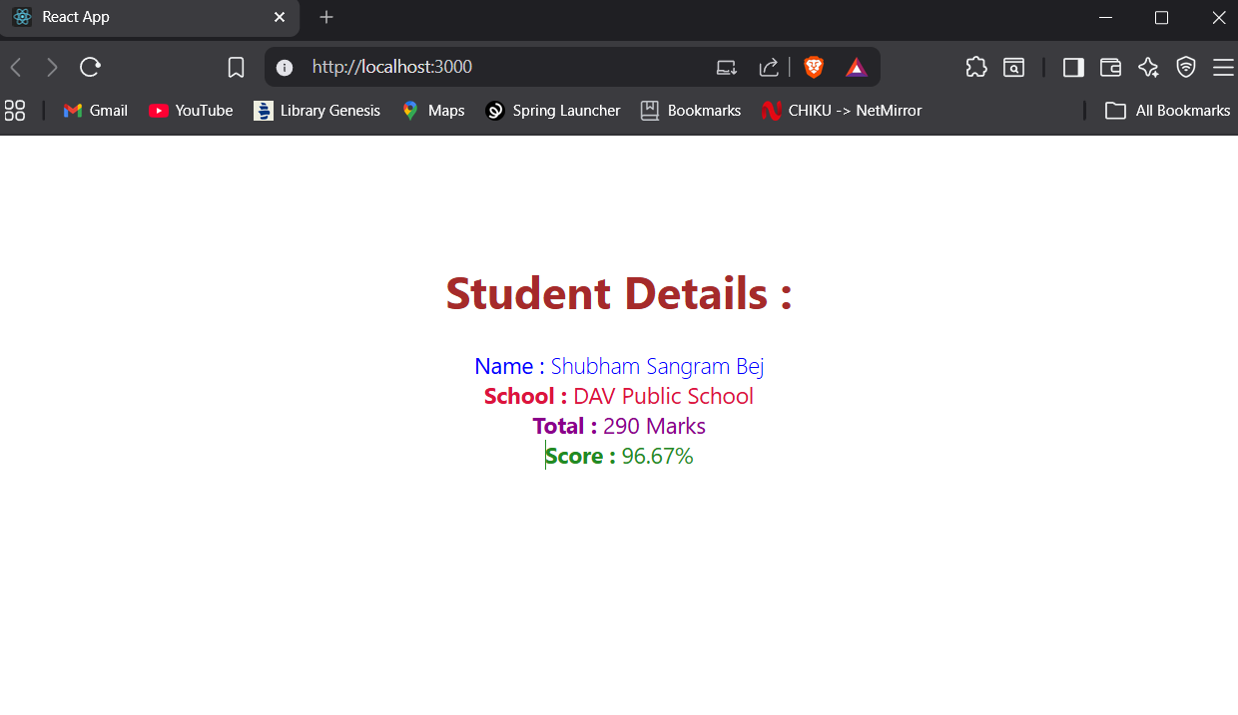

Result
The React application scorecalculatorapp was successfully created. A Function Component was implemented using Props and CSS styling, and the student's percentage score was calculated and displayed successfully.

